槟城恒毅(国民型)中学国际少年服务团
INTERACT CLUB
SMJK HENG EE, PULAU PINANG
99,Jalan Hamilton, 11600 Pulau Pinang.
Tel:042824402

48th District Interact Conference
On the 4th December 2015 , the BOD of Interact Club Of HengEe High School attended a four days three nights district conference which . The 48th District Interact Conference R.T. District 3300 was held at PangkalanTLDM ,Lumut , Perak on 4th -7th December 2015. The 48THDistrict Interact Conference was hosted by The Rotary Club of Klang .
The objective of this District Interact Conference is to provide a platform for Interactors to develop their leadership skills and personal integrity , to demonstrate helpfulness and respect for others ,to understand the value of individual responsibility and hard work . and to advance international understanding and goodwill .
Participating Interactos :

INT. TNEH XUAN ( President )
INT. Lim Hong Ze ( Vice President )
INT. Gene H’ng Wei Tian( Vice President )

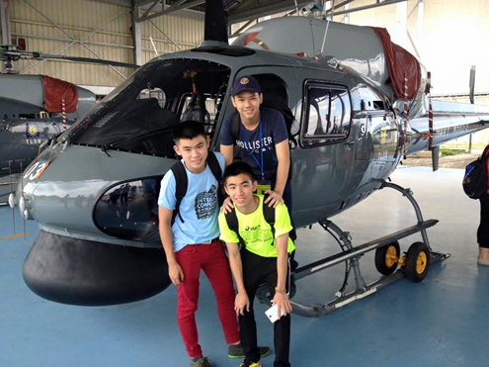

Below are the details of the conference :

槟城恒毅(国民型)中学国际少年服务团
INTERACT CLUB
SMJK HENG EE, PULAU PINANG
99,Jalan Hamilton, 11600 Pulau Pinang.
Tel:042824402

Day 1 – 4th December 2015 (Friday )
7:30am – 1:00pm
The participants started to arrive and were directed towards the Auditorium M.Sidek , where they could register themselves and to freshen up . After registration , participants were brought to their respective rooms .
12:00pm
Lunch was served for all the participants . Participants were able to satisfy their hunger , quench their thirst as well as begin to mix with the crowd and to get to know each other.
2:30pm
At this time , all the participants were asked to gathered at the Auditorium M.Sidek . A short briefing for the house rules were given by Dato Master PP Rtn. A.R. Peter and the TLDM Officer , Lt. Kdr. ShahrulAzimalHjIberahim& P W 1 PBS Mohammad Izani bin Shafii .
2:50pm
A speaker ,CikRoziahBintiRoslan gave us all a talk entitled “Relationships & Expectations of School Management from Interactors “.
4:20pm
All participants were classified into 3 different groups , group A , B and C .Three demonstrations , which were Team Building , Jungle Survivial& Firing , and Diving Centre , were shown to all the participants by the TLDM officers.
6:30pm
An Ice Breaking session was held at Drill Shade by the First Admiral DatoSubramaniam Raman(R) .
8:45pm
Dinner was served at the dining hall.
9:15pm
A speaker ,Dato Master PP Rtn A. R. Peter gave a talk about “Interactors :Leader of the Future”.
10:30pm
Lights out.

槟城恒毅(国民型)中学国际少年服务团
INTERACT CLUB
SMJK HENG EE, PULAU PINANG
99,Jalan Hamilton, 11600 Pulau Pinang.
Tel:042824402

Day 2 – 5th December 2015 (Saturday)
5:30am
Wakie-Wakie.
6:30am
Breakfast was served at the dining hall .
8:30am
The opening ceremony was held at the AudioriumM.Sidek. Speeches were given by the Oranisingchairman , Interact representative , Hostclub president and the District Governor .
9:45am
High tea was served for all participants .
11:00am
TLDM demonstrations were continued.
1:00pm
Lunch was served at the dining hall .
2:00pm
Once again , TLDM demonstrations were continued .
4:30pm
A talk entitled “Exposure of Youths to Criminal Activities was given by “AG Rtn Gerard Lazarus”
5:45pm
Rehearsal and preparation works for the talent time were carried out .
6:30pm
Dinner was served.
7:00pm – 10:00pm
Talent Time Session. After the Talent Time Session , Emcees announced the winner of the Talent time went to team “Mickey”.
10:30pm
Lights out .

槟城恒毅(国民型)中学国际少年服务团
INTERACT CLUB
SMJK HENG EE, PULAU PINANG
99,Jalan Hamilton, 11600 Pulau Pinang.
Tel:042824402

Day 3 – 6TH December 2015 ( Sunday )
5:30am
Wakie –wakie
6:30am
Breakfast was served.
8:00am -12:00pm
TLDM Demonstrations of TLDM Battle Ships ,MarkasUdara and Navigation Training &Galeri PTL , were presented by the TLDM officers .
1:00 pm
Lunch was served at the Dining Hall .
1:30pm-4:00pm
TLDM demonstrations were continued.
4:30pm-6:30pm
Speaker DRR, Rot. Steven Ting Boon Hee gave us all a talk of topic : “What is Roteract ?”
After the speech by DRR, Rot. Steven Ting Boon HEE , a talk entitled “Motivation and Ethnics” was given by the First Admiral DatoSubramaniam Rahman (R) .
7:00pm
Dinner was served at the dining hall.

9:00pm
An experienced speaker ,Dato Wei ChuanBeng , gave us all a talk about “My Journey from an Interactor to an Entreprenuer .
10:30pm
Light out.

槟城恒毅(国民型)中学国际少年服务团
INTERACT CLUB
SMJK HENG EE, PULAU PINANG
99,Jalan Hamilton, 11600 Pulau Pinang.
Tel:042824402

Day 4-7TH December 2016 .
5:30am
Wakiewakie and check out . All participants were required to pack up and bring their luggages to the Auditorium.
6:30am
Breakfast was served.
8:00am-9:30am
A speker ,Datuk PP Rtn Dr. Puraviappan , gave a talk about “Physiological Growth In Teenagers”
After the talk by Datuk PP Rtn Dr. Puraviappan , a talk entitled “Career Development”was given by the MAHSA University Professor.
10:00am
Tea break was served at the dining hall.
10:30am
A speaker , PDG Rtn Leslie Salehuddin gave us all a talk entitled “From Good to Great …….Your Journey as an Interactor .

11:15am
Closing ceremony was held at the Auditorium M.Sidek .

槟城恒毅(国民型)中学国际少年服务团
INTERACT CLUB
SMJK HENG EE, PULAU PINANG
99,Jalan Hamilton, 11600 Pulau Pinang.
Tel:042824402

Certificates were distributed to the representatives of each of the Interact club .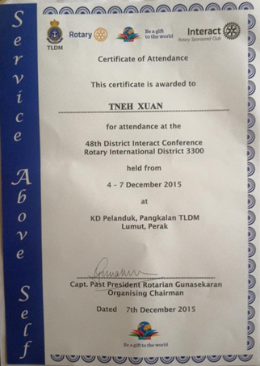

12:00pm
Lunch was served at the Dining hall .
Group photo was taken at the Auditorium M.Sidek.
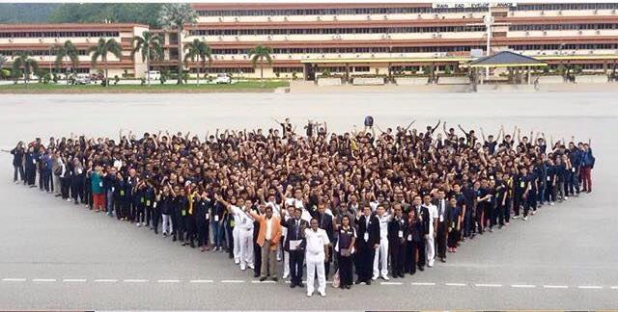
2:00pm
Break camps .
All participants were departed the TLDM LUMUT base respectively.

Report Prepared by,

___________________
TnehXuan
President (15/16 )
Interact Club
HengEe High School.

