槟城恒毅(国民型)中学国际少年服务团
INTERACT CLUB
SMJK HENG EE, PULAU PINANG
99, Jalan Hamilton, 11600 Pulau Pinang.
Tel: 042824402

CAR WASH PROJECT

Date | : 9th May2015
Time | : 8.00 am – 2.00 pm
Venue | :Penang Automatic Car Wash Centre  124. Jalan Macalister, 10400 Georgetown, Penang.
Attendance | : 34 members

AGENDA
8.00am | -Gather at car wash center.
8.15am | - Start washing the cars.
12.00pm | - Lunch time.
1.00pm  2.00pm | - Resume work.  - End.

SERVICE ABOVE SELF

Thank you.

Prepared by,  ____________________  (CHONG WEN NI)  Vice Secretary,  Interact Club,  HengEe High School. | Approved by,  ____________________  Madam Ooi Hon Bu,  Teacher Advisor,  Interact Club,  HengEe High School.

槟城恒毅(国民型)中学国际少年服务团
INTERACT CLUB
SMJK HENG EE, PULAU PINANG
99, Jalan Hamilton, 11600 Pulau Pinang.
Tel: 042824402

CAR WASH PROJECT

Date | : 9th May 2015
Venue | : Penang Automatic Car Wash Centre  124. Jalan Macalister, 10400 Georgetown, Penang.
Objectives | : 1) Strengthen the ties between interactors.  2) Enrich interactors’ experience.  3)Raise funds and providing to the needs of society.

On 9th of May 2015, our club organized a car wash project to raise funds for construction of SMJKHengEe branch schooland providing to the needs of society. We start sold car wash coupons for RM10.00 each in April and May to the public.

The car wash project took place from 8am until 2pm. After reporting in, all the members were then assigned to various stations according to their respective jobs - pre washing, washing, drying and vacuuming.

Later that day, more and more customers arrived. We were very busy but we worked very hard and cooperated well. As a result, everything progressed smoothly as planned. Throughout the day, we washed and vacuumed almost 100 cars.

We are grateful to Penang Automatic Car Wash Centre for rendering their place. We also appreciate the hard work and cooperation of all the members in making this fund raising event a great success.

槟城恒毅(国民型)中学国际少年服务团
INTERACT CLUB
SMJK HENG EE, PULAU PINANG
99, Jalan Hamilton, 11600 Pulau Pinang.
Tel: 042824402

CAR WASH PROJECT

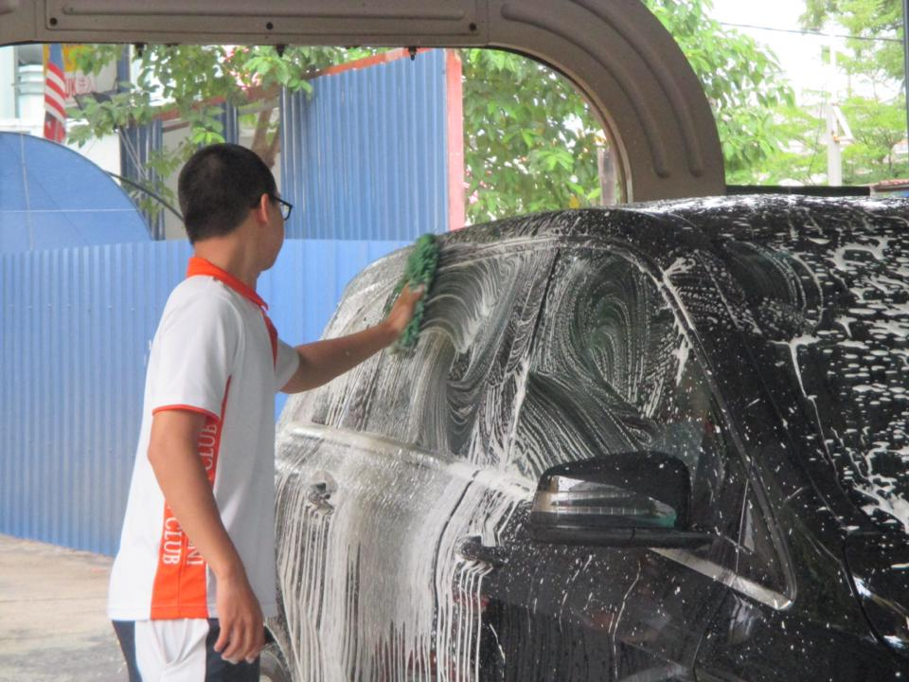
Interactor is washing the car with soap.

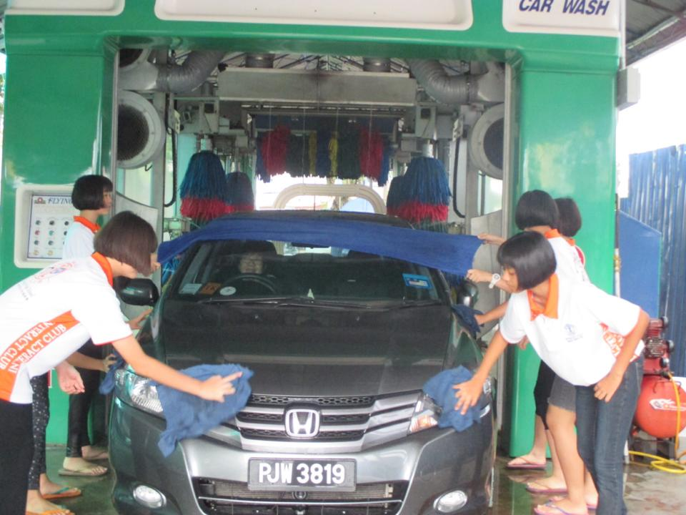
Few interactors in charge to drying the car.

