槟城恒毅(国民型)中学国际少年服务团
INTERACT CLUB
SMJK HENG EE, PULAU PINANG
99,Jalan Hamilton, 11600 Pulau Pinang.
Tel:042824402

REPORT OF VISITING THE OLD FOLKS HOME
Date | : 28th January 2015
Time | : 9.00am – 11.00am
Venue | : Rumah Orang Tua Uzur Pulau Pinang  409, Jalan Masjid Negeri, 11600 Pulau Pinang.
Attendance | : 42 members
AGENDA
8.00am | - Meet at the school foyer
8.30am | - Take the bus to Old Folks Home
8.45am | - Prepare the equipmentfor the event
9.00am | - Event start
10.30am | - Event ends and clean up the venue
11.00am | - Dismiss
SERVICE ABOVE SELF

Thank you.

Prepared by,  ____________________  (TAN KE XIN)  Secretary,  Interact Club,  Heng Ee High School | Approved by,  ____________________  (MADAM OOI HON BU)  Teacher Advisor,  Interact Club,  Heng Ee High School

槟城恒毅(国民型)中学国际少年服务团
INTERACT CLUB
SMJK HENG EE, PULAU PINANG
99,Jalan Hamilton, 11600 Pulau Pinang.
Tel:042824402

REPORT OF VISITING THE OLD FOLKS HOME
Date | : 28th January 2015
Venue | : Rumah Orang Tua Uzur Pulau Pinang  409, Jalan Masjid Negeri, 11600 Pulau Pinang.
Objectives | : carried out with the cooperation between the PTA and school adminstration to  - celebrate Chinese New Year  - show our love towards the elderly who are being neglected  - give the students a chance to interact with the old folks
The trip to the old folks' home is an annual school project where the school has a donation drive to collect money from the whole school and the proceeds are given to the old folks in the form of money and angpau. These donations are given to make the old folks happy and to make sure that their needs are well taken care of. This year's trip was a success thanks to everyone's cooperation. However, the shows performed by the students were limited as they were short of time. We hope that the performance time can be extended so that the students have enough time to perform and entertain the old folks.

槟城恒毅(国民型)中学国际少年服务团
INTERACT CLUB
SMJK HENG EE, PULAU PINANG
99,Jalan Hamilton, 11600 Pulau Pinang.
Tel:042824402

REPORT OF VISITING THE OLD FOLKS HOME
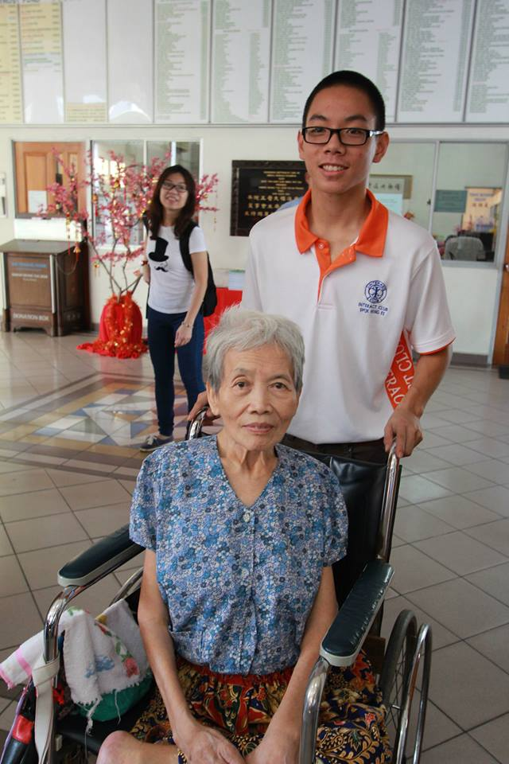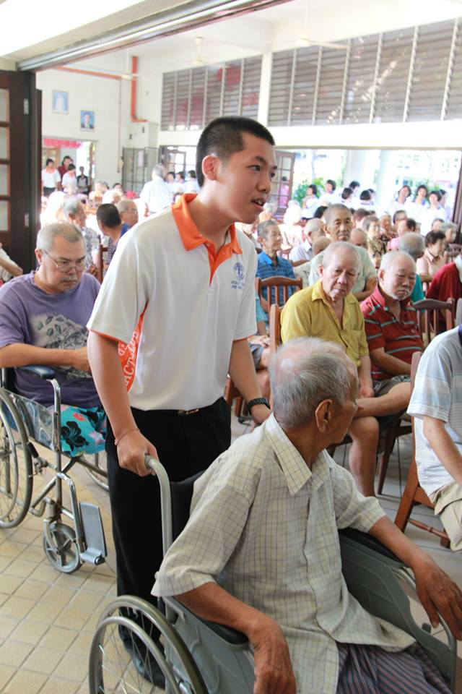
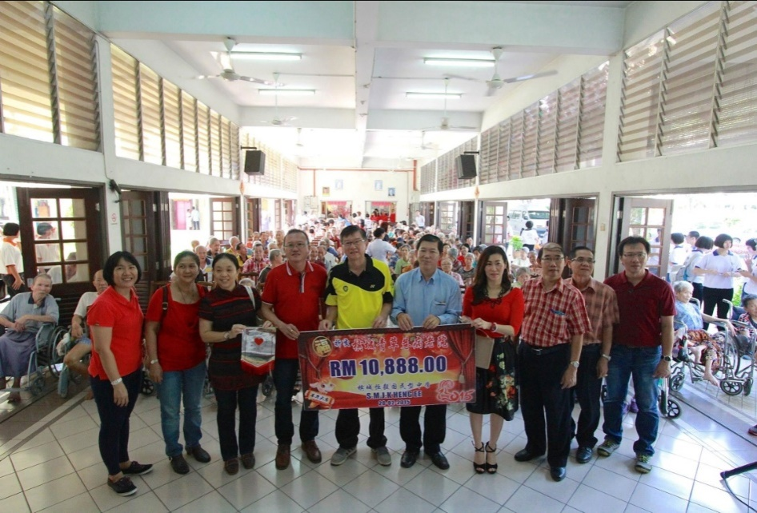

槟城恒毅(国民型)中学国际少年服务团
INTERACT CLUB
SMJK HENG EE, PULAU PINANG
99,Jalan Hamilton, 11600 Pulau Pinang.
Tel:042824402

REPORT OF VISITING THE OLD FOLKS HOME
